# Privacy-Preserving Cybersecurity Threat Detection System: Proposal and Implementation Plan

## Executive Summary

This report proposes a novel Privacy-Preserving Cybersecurity Threat Detection System designed to address the growing cybersecurity challenges faced by financial institutions while maintaining robust privacy protections. The system leverages advanced privacy-enhancing technologies (PETs) to facilitate secure collaboration between financial institutions, regulatory bodies, and cybersecurity firms without compromising sensitive data. Specifically, the system employs Homomorphic Encryption, Federated Learning, and Differential Privacy to achieve its privacy-preserving goals.

Table of Contents

Privacy-Preserving Cybersecurity Threat Detection System: Proposal and Implementation Plan 1

Executive Summary 1

Background and Problem Statement 1

System Architecture 1

Data Flow Diagram 2

Privacy-Enhancing Technologies (PETs) Implementation 2

Homomorphic Encryption 2

Federated Learning 3

Differential Privacy 5

Integration of PETs 6

Collaboration Mechanisms 6

Secure Information Sharing Platform 6

Standardized Data Formats and APIs 7

Challenges and Solutions 7

Regulatory Compliance 7

Performance and Scalability 7

Balancing Privacy and Effectiveness 8

Implementation Plan 8

Effectiveness Metrics 9

Conclusion 9

Next Steps 9

## Background and Problem Statement

Financial institutions face increasingly sophisticated cyber threats, necessitating advanced detection and response capabilities. However, effective threat detection often requires the analysis of sensitive data and collaboration between multiple entities, raising significant privacy concerns. This project aims to develop a system that balances the need for comprehensive threat detection with stringent privacy requirements.

## System Architecture

The proposed system consists of the following key components:

* Data Ingestion Layer
* Privacy-Preserving Analytics Engine
* Collaborative Learning Module
* Secure Information Sharing Platform
* Automated Response Orchestrator

### Data Flow Diagram

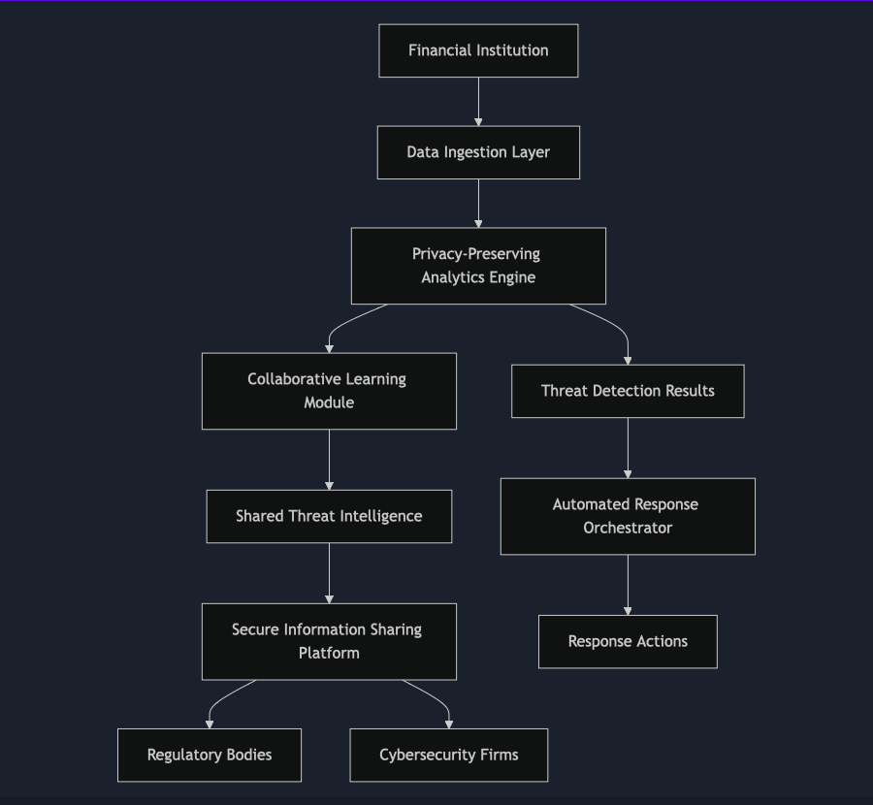

## Privacy-Enhancing Technologies (PETs) Implementation

### Homomorphic Encryption

**Implementation Details:**

We will use the SEAL (Simple Encrypted Arithmetic Library) developed by Microsoft Research for implementing fully homomorphic encryption.

**Key Components:**

1. **Encryption Service:** Encrypts sensitive data before it enters the analytics pipeline.
2. **Homomorphic Operation Module:** Performs computations on encrypted data.
3. **Decryption Service:** Decrypts results for authorized users.

**Workflow:**

1. Financial transaction data and network logs are encrypted using the public key.
2. The Privacy-Preserving Analytics Engine performs threat detection algorithms on the encrypted data.
3. Results are decrypted only by authorized personnel using the private key.

**Example Use Case:**

Detecting anomalous transactions without exposing actual transaction amounts:

**Performance Considerations:**

* Use of lattice-based cryptography for efficient homomorphic operations.
* Implement batch processing to amortize the computational overhead.

### Federated Learning

**Implementation Details:**

We will develop a federated learning framework using TensorFlow Federated (TFF).

**Key Components:**

1. **Local Model Trainer:** Runs on each financial institution's secure environment.
2. **Federated Aggregator:** Centralized service that aggregates model updates.
3. **Global Model Distributor:** Distributes updated global model to participants.

**Workflow:**

1. Each institution trains a local model on their private data.
2. Model updates (not raw data) are sent to the Federated Aggregator.
3. The Aggregator combines updates to improve the global model.
4. The updated global model is distributed back to all participants.

**Example Use Case:**

Training a neural network to detect new types of cyber-attacks:

**Privacy Safeguards:**

* Implement secure aggregation to prevent leakage from model updates.
* Use differential privacy in local training to add noise to individual contributions.

### Differential Privacy

**Implementation Details:**

We will integrate Google's Differential Privacy library to add controlled noise to data and model outputs.

**Key Components:**

1. **DP Query Engine:** Handles database queries with differential privacy guarantees.
2. **DP Model Trainer:** Applies differential privacy to machine learning model training.
3. **Privacy Budget Manager:** Tracks and manages the privacy budget across the system.

**Workflow:**

1. Set a privacy budget (epsilon) for each type of operation.
2. Apply DP mechanisms (e.g., Laplace Mechanism) to add noise to query results or model outputs.
3. Track privacy expenditure and halt operations if the budget is exceeded.

**Example Use Case:**

Releasing aggregated statistics about cyber incidents:

**Balancing Act:**

* Carefully tune epsilon values to balance privacy protection and the utility of results.
* Implement adaptive privacy budgets that adjust based on the current threat landscape.

### Integration of PETs

The true power of our system comes from the integration of these three PETs:

1. HE protects raw data during analysis.
2. FL enables collaborative learning without data sharing.
3. DP ensures that outputs and model updates don't leak individual information.

**Example Integrated Workflow:**

1. Financial institutions encrypt their cybersecurity logs using HE.
2. Encrypted logs are analysed using homomorphic operations to detect threats.
3. The results of this analysis are used to train local models using DP.
4. Local model updates are shared and aggregated using FL.
5. The improved global model is distributed back to all participants.

This integrated approach provides multiple layers of privacy protection while still enabling effective, collaborative cybersecurity threat detection.

## Collaboration Mechanisms

### Secure Information Sharing Platform

A dedicated platform will be developed to facilitate secure information sharing between participating entities.

**Features:**

* End-to-end encryption for all communications
* Granular access controls and audit logging
* Real-time threat intelligence sharing capabilities

### Standardized Data Formats and APIs

To ensure interoperability, the system will adopt standardized data formats and APIs.

**Standards:**

* STIX (Structured Threat Information eXpression) for threat intelligence
* TAXII (Trusted Automated eXchange of Intelligence Information) for sharing protocols

## Challenges and Solutions

### Regulatory Compliance

**Challenge:**

Meeting diverse regulatory requirements across jurisdictions.

**Solution:**

Implement a flexible compliance module that can be configured to meet specific regulatory needs. Engage with regulatory bodies early in the development process.

### Performance and Scalability

**Challenge:**

Ensuring system performance with computationally intensive PETs.

**Solution:**

Utilize cloud-based infrastructure for scalability. Implement efficient algorithms and consider hardware acceleration for cryptographic operations.

### Balancing Privacy and Effectiveness

**Challenge:**

Maintaining detection accuracy while implementing strong privacy measures.

**Solution:**

Conduct thorough testing to optimize the trade-off between privacy and effectiveness. Implement adaptive privacy budgets based on threat levels.

## Implementation Plan

**Phase 1: Design and Prototyping (3 months)**

* Finalize system architecture
* Develop prototypes for key components
* Engage with stakeholders for feedback

**Phase 2: Core Development (6 months)**

* Implement a privacy-preserving analytics engine.
* Develop a collaborative learning module.
* Create a secure information-sharing platform.

**Phase 3: Integration and Testing (3 months)**

* Integrate all system components.
* Conduct thorough security and privacy audits.
* Perform large-scale simulations with synthetic data.

**Phase 4: Pilot Deployment (3 months)**

* Deploy the system with a small group of partner institutions
* Gather real-world performance data
* Refine system based on feedback

**Phase 5: Full Rollout and Ongoing Improvement (6 months+)**

* Gradual rollout to all participating institutions
* Establish continuous monitoring and improvement processes
* Regular updates to address emerging threats and technologies

## Effectiveness Metrics

The system's effectiveness will be measured using the following key performance indicators (KPIs):

1. **Threat Detection Rate:** Percentage of actual threats successfully identified
2. **False Positive Rate:** Percentage of benign activities incorrectly flagged as threats
3. **Privacy Preservation Score:** Quantitative measure of how well individual privacy is maintained
4. **Collaboration Effectiveness:** Measure of improved threat detection through shared intelligence
5. **Response Time:** Time taken from threat detection to mitigation action

## Conclusion

The proposed Privacy-Preserving Cybersecurity Threat Detection System represents a significant advancement in balancing effective threat detection with stringent privacy requirements. By leveraging cutting-edge PETs and fostering secure collaboration, this system has the potential to significantly enhance the cybersecurity posture of financial institutions while maintaining the trust and privacy of their customers.

## Next Steps

1. Secure funding and resources for the project
2. Establish partnerships with key stakeholders (financial institutions, regulators, technology providers)
3. Begin Phase 1 of the implementation plan
4. Develop a comprehensive risk management strategy for the project